Ansible to Orchestrator transition

Remove Old Archived Logs
Solution architecture
System | Windows event log archives
Platform | VCF Operations Orchestrator 9
Workflow | Clean Archived Event Logs from File Share
Workflow ID | b453f157-9cc7-48c5-855e-b1f666141897
Orchestrator | cvsd26vcfauto01.connect.lab
Replaces | One Ansible function, Remove-OldFiles-UNCPath
Source of truth | GitLab, psscript repository
Script delivery | Manual today; pipeline planned
Credentials at run time | None — held on the plug-in endpoint
Active Directory | Not used — see section 3
Status | Deployed; one reporting defect outstanding

Scope of this document
This document describes Remove Old Archived Logs as a standalone automation. It can be read, and the automation installed, without reference to anything else — including into an Orchestrator with no Active Directory plug-in configured at all.
It has a partner — Move Archived Logs — which is what puts files on the share this one cleans. That is a separate automation with its own architecture document. Neither needs the other to work: this one will clean any share, whatever put the files there. Where the two share a component, this document says so explicitly.

Contents
Contents 2
1. What the automation does 3
1.1 What it replaces 3
1.2 The interactive prompt had to go 3
2. Context 4
3. Run-time architecture 4
3.1 What each element does 4
3.2 The data path 5
4. Components 6
4.1 This automation only 6
4.2 Shared with Move Archived Logs 6
5. Security model 7
5.1 Read and delete are different permissions 7
5.2 The second hop 7
5.3 Paths must be names, never IP addresses 8
6. Getting code into Orchestrator 9
7. Failure behaviour and observability 9
7.1 The result-line contract 9
7.2 One unreadable folder must not abandon the share 9
7.3 Errors say which operation failed 10
7.4 Partial success is a real state 10
9. What was deliberately left out 11

1. What the automation does
Files accumulate on the archive share. This automation deletes those past their retention period, so the share does not grow without bound.
It works on a share, not on a list of servers. An operator checks two values — how old, and whether this is a real run — and submits.

1.1 What it replaces
One function out of the Ansible toolbox: Remove-OldFiles-UNCPath, run from remove-OldFiles-UNCPath.yml.
Unlike the four move playbooks, there was only ever one of these, and its core logic was sound. The retention arithmetic was correct, the path was validated, and per-file errors were counted rather than allowed to stop the run. Most of what follows is therefore not a correction — it is the same job made to work unattended, which is the one thing it could not do.
The toolbox also carried a second, more dangerous function, Remove-files, which piped matches straight into Remove-Item -Force -Recurse. That one is not carried forward: it could remove directories as well as files, and a recursive delete is not something an unattended job should be able to reach for.

1.2 The interactive prompt had to go
This is the change that mattered. The original asked, at the console:
if (-not $Force -and -not $WhatIfPreference) {
$Confirmation = Read-Host "Are you sure you want to delete these files? (Y/N)"
if ($Confirmation -ne 'Y') {
write-log "Info: Operation cancelled by user" $true
return
}
}
On an automated run there is nobody there. Read-Host either blocked the job or read empty input — which is not Y — so the function returned having deleted nothing and logged it as a *user cancellation*.
The safety feature therefore never worked as a safety feature. It worked as an obstacle: to make the job run at all you passed -Force, and -Force skipped the confirmation entirely. The only two available modes were hangs and no preview at all.
What replaces it
reportOnly defaults to on. A run that is not explicitly told to delete will only ever list what it would have deleted. It does the job the prompt was meant to do, it works with nobody watching, and — unlike the prompt — the preview is a real run whose output can be read afterwards in the workflow transcript.

2. Context
The figure below shows the whole event log archive solution: how code reaches Orchestrator, and what happens at run time. Deployment runs down the page; everything at run time runs across it.
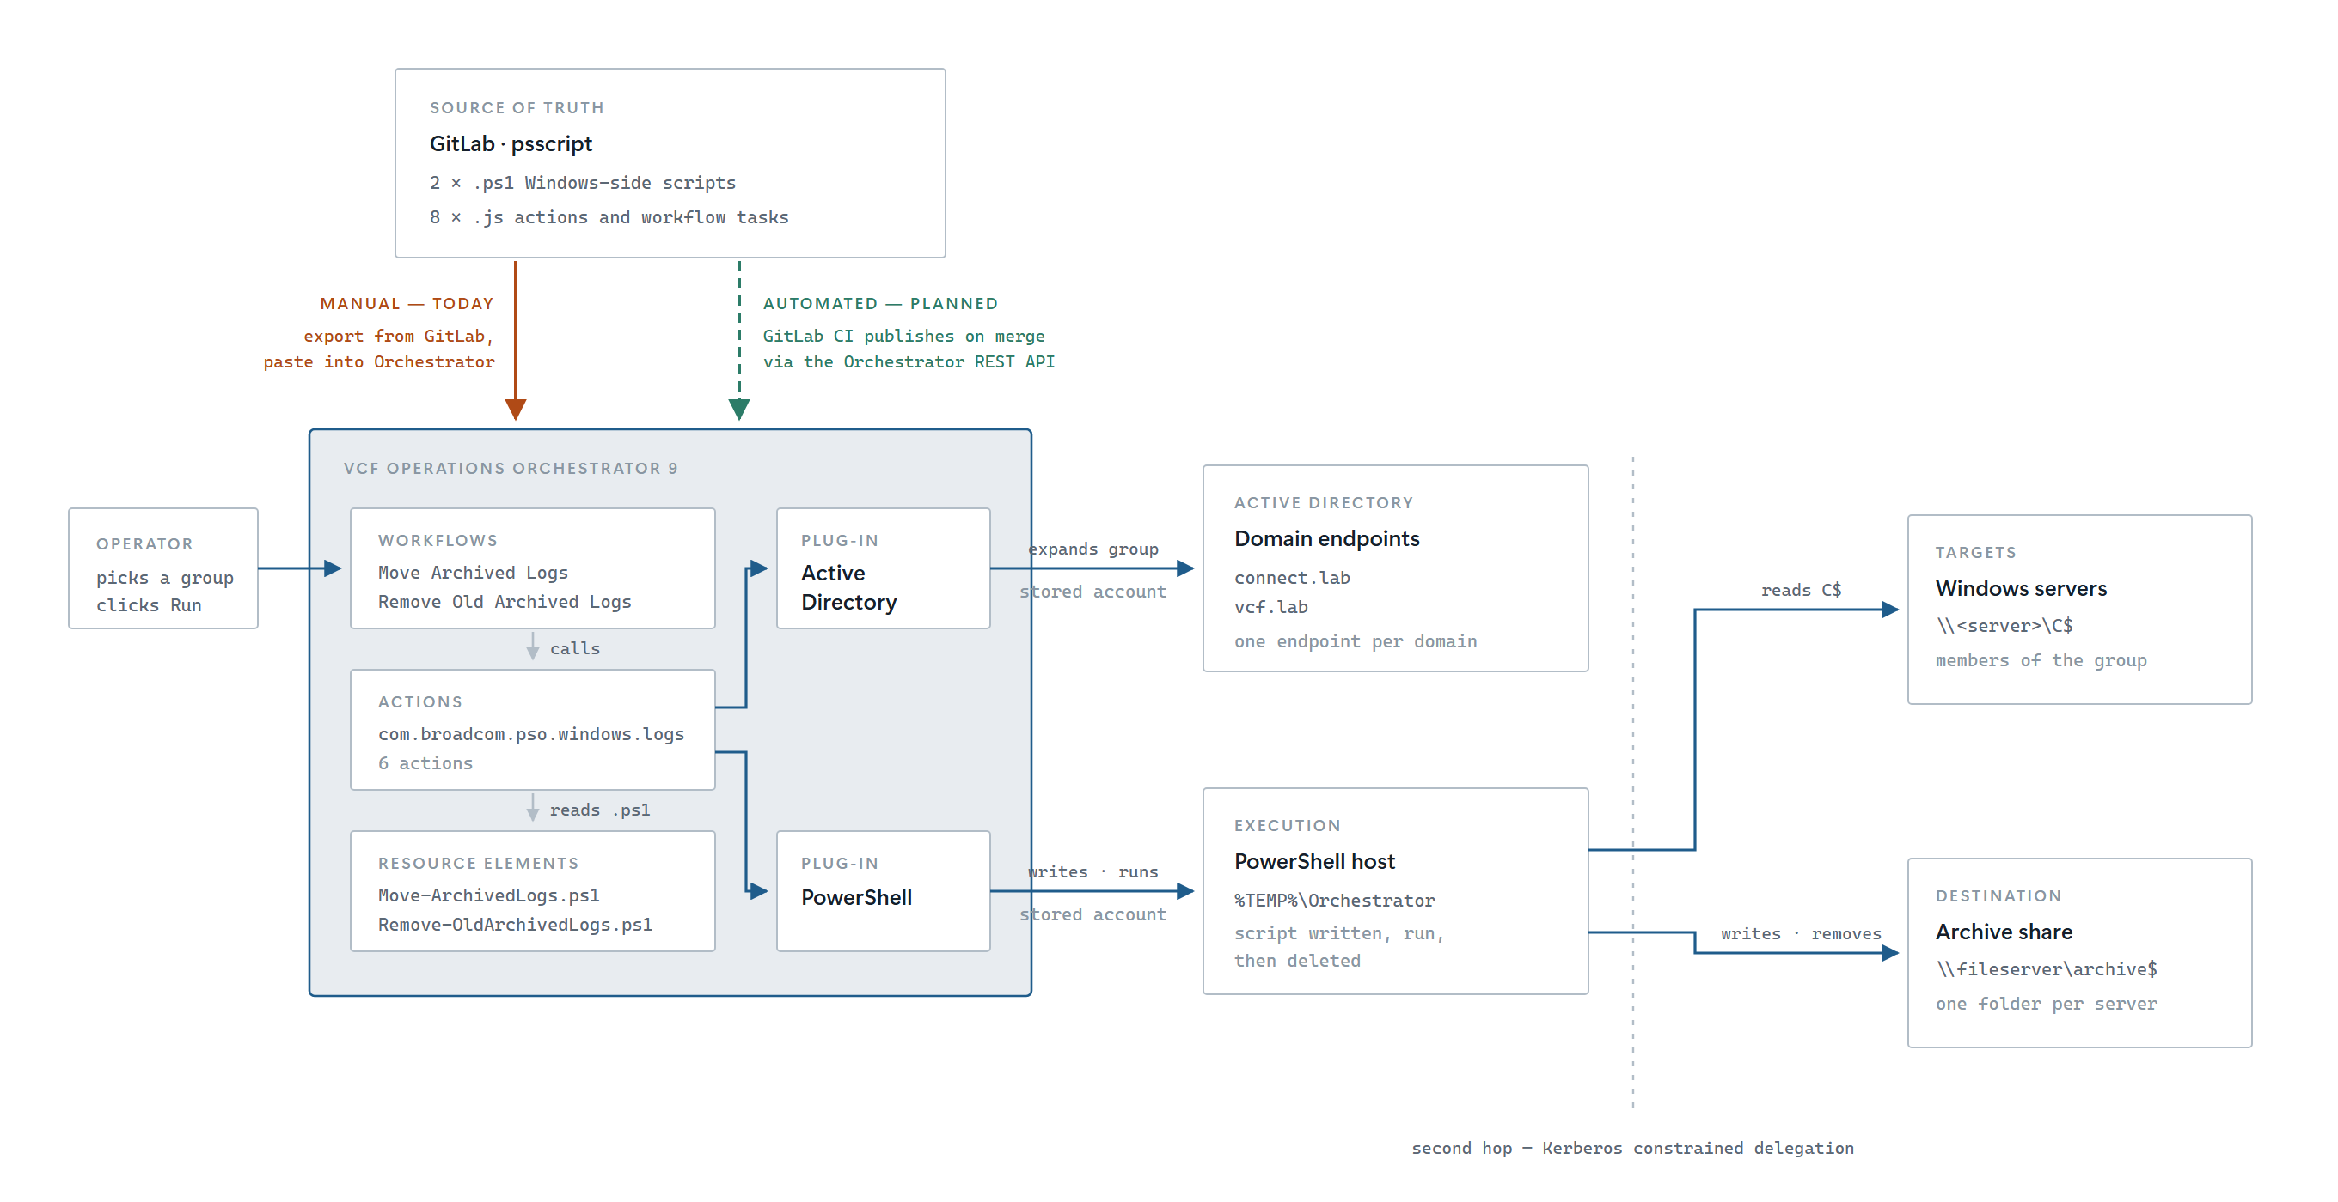
Figure 1 — The whole path, from repository to estate
What this document covers
The figure shows both automations in this family. This document covers only the right-hand end of the run-time path: the PowerShell host reaching the archive share.
Everything on the Active Directory side — the plug-in, the domain endpoints, the expansion of a group into servers — belongs to the Move Archived Logs workflow. This automation uses none of it, and needs none of it configured.

3. Run-time architecture
Three elements end to end. Each takes its inputs from the attribute the element before it wrote, so the schema itself records where every value came from. Nothing is fetched with System.getModule() inside a task, and nothing is looked up by name at run time.
Create Script Parameters -> runPowerShellScript -> Parse Result -> end

3.1 What each element does
# | Element | Kind | What it contributes
1 | Create Script Parameters | Scriptable task | Validates the path and the retention, warns on an IP address, converts the tick-box, builds the parameter set
2 | runPowerShellScript | Action *(shared)* | Copies the script to the host, runs it, parses the single result line, returns it
3 | Parse Result | Scriptable task | Splits that result into the workflow outputs and reports errors individually

3.2 The data path
runPowerShellScript writes Remove-OldArchivedLogs.ps1 into %TEMP%\Orchestrator on the PowerShell host, invokes it by path, captures everything it printed, and deletes the file. The script enumerates the share recursively, filters by last-write time, and deletes matching files one at a time.
Why the script is written to disk rather than piped in
Invoked by path, it runs exactly as it would if an administrator ran it by hand — so what you test at a console is what the workflow does. Deleting it afterwards means no stale copy is left to drift out of step with the version held in Orchestrator.

Files are deleted individually rather than piped as a set into Remove-Item. One locked or protected file is then reported and skipped while the cleanup continues; piped, its error behaviour depends on the preference in force, and under Stop a single open log file ends the run. A file being open is the ordinary case here, not the exception — these are event log archives on a share another job writes to.
Folders are left alone. Only files are deleted, so a server folder stays on the share between archive runs rather than vanishing and reappearing.

4. Components
Seven files, of which four are shared with the partner automation and only three are this automation own. The split follows one rule: anything that runs a script on a Windows host is shared; anything that decides which servers belongs to the partner. This automation has no servers.

4.1 This automation only
Component | Kind | Responsibility
Remove-OldArchivedLogs.ps1 | Resource Element | The Windows-side work: enumerate, filter by age, delete, report
Create Script Parameters | Scriptable task | Validates, warns on an IP path, builds the parameter set
Parse Result | Scriptable task | Result to workflow outputs

4.2 Shared with Move Archived Logs
Component | Kind | Note
runPowerShellScript | Action | The only place that knows anything about the PowerShell plug-in. Required

5. Security model
Nothing in this automation accepts a username or a password. The PowerShell plug-in uses the account stored against the host.
Hop | Runs as | Held where
Orchestrator to PowerShell host | The host account | On the PowerShell:PowerShellHost object
PowerShell host to archive share | The same account, delegated | Kerberos — see below

5.1 Read and delete are different permissions
This is the distinction this automation turns on, and the one most likely to be missed.
Operation | Needs | Exercised by
Listing the share | Read | Every run, including report-only
Deleting a file | Delete | Only a live run

A clean report-only run does not prove the files can be deleted
Report only reads the share and never writes to it. An account with read but not delete produces a flawless report — every file correctly identified, no errors — and then fails on every single file the moment the box is unticked. No amount of re-running the report will reveal it. The only way to establish delete permission is to delete something.

The script says as much in its own log rather than leaving it to be discovered.

5.2 The second hop
Orchestrator connects to the PowerShell host; the host then reaches the archive share. That is a separate authentication, and by default Windows will not forward the credential to it. The host must be set to Kerberos — Basic and NTLM cannot carry a credential to a second machine at all — and the connection must actually delegate, which is a separate condition worth verifying rather than assuming.
klist ticket flags on the host | Meaning
forwardable forwarded | The credential was delegated. The second hop will work
forwardable alone | The ticket could have been delegated but was not
No krbtgt ticket, only HOST/<pshost> | No delegation at all. The session can act only on the host itself

Because this automation reaches exactly one machine, resource-based constrained delegation is straightforward here: it needs configuring on the file server alone, not across an estate.
A console logon proves nothing
Logging on to the PowerShell host at the console or over RDP and browsing to the share will succeed whether delegation is configured or not. Both hold primary credentials and can authenticate onward; a WinRM session cannot. Same account, same rights, different logon type — and the workflow uses the one that fails. Verification has to happen in a session Orchestrator opened.

5.3 Paths must be names, never IP addresses
Kerberos authenticates to a service principal name, built from a host *name*. There is none for an IP address, so a UNC path written with one cannot use Kerberos at all: it falls back to NTLM, the delegated credential is useless to it, and the share answers Access is denied.
This automation has exactly one path, so it is entirely exposed to this. There is no second, working path to compare against, and no way to tell it apart from a share-permissions fault by reading the error.
Both the script and the first task warn when given an IP, rather than refusing — a local path or a mapped drive is legitimate, and the caller may know something the check does not. The script emits its warning *before* the reachability test, which on an unreachable IP takes about twenty seconds to fail, so the cause appears in the log ahead of the symptom.

6. Getting code into Orchestrator
The repository is the source of truth. Orchestrator holds a copy, and the copy is made by hand today.
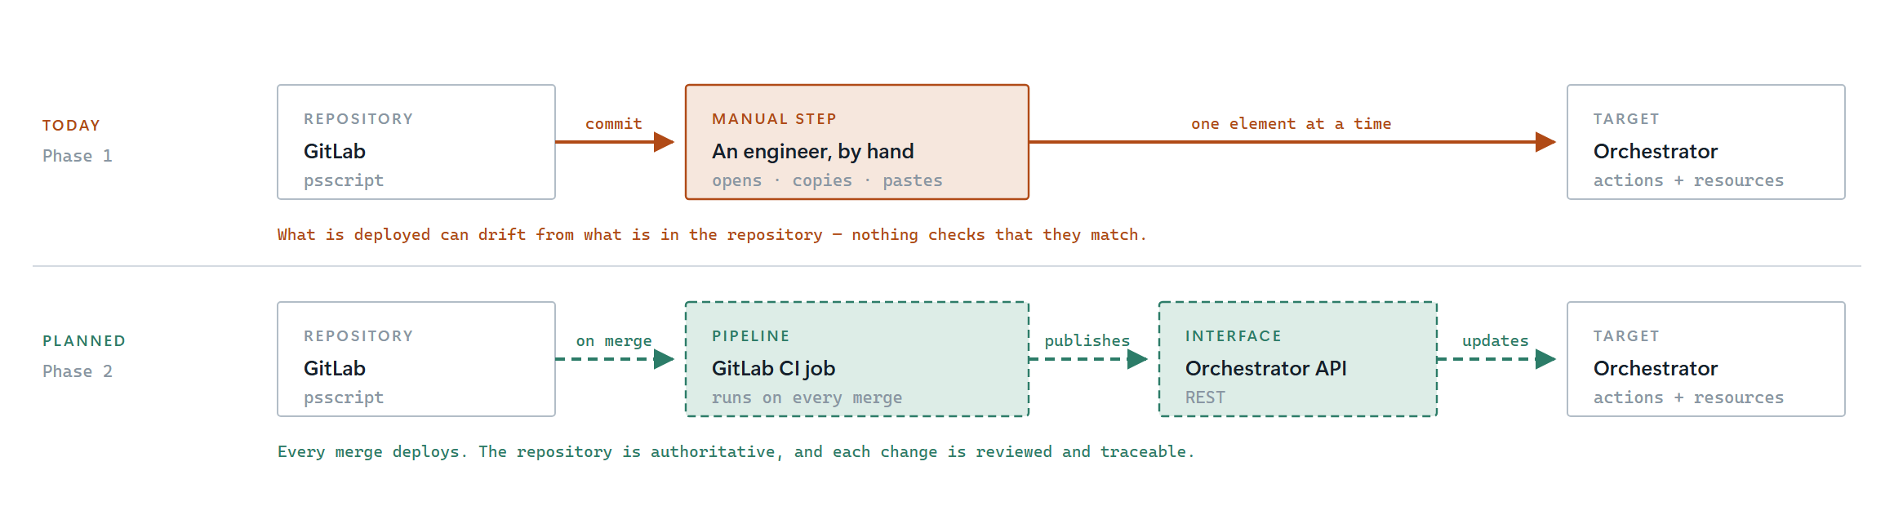
Figure 2 — Code delivery, today and planned
What this document covers
This path is shared by both automations in the family and is a build-time concern. It is not another hop in the run-time data path, and nothing in it runs while the workflow runs.

Until the pipeline exists, the repository and Orchestrator can disagree and nothing will say so. That is a deliberate, recorded gap rather than an oversight.

7. Failure behaviour and observability

7.1 The result-line contract
The script prints readable log lines for people, and exactly one line for Orchestrator:
PSO_RESULT={"matched":412,"deleted":412,"freedMB":1180.44,"errorCount":0,"errors":[]}
That line is always printed — even when the script deletes nothing, and even when it refuses to run at all. Because it is always printed, its absence means something real: the script did not finish. runPowerShellScript treats a missing result line as a failure rather than as "zero files".

7.2 One unreadable folder must not abandon the share
The original stopped on the first enumeration error. On a share of any size some folder eventually cannot be read — a per-folder ACL, a protected subdirectory, something another job created — and the first one then ends the enumeration, leaving the rest of the share uncleaned.
There is a worse consequence in the Orchestrator setting. The error is terminating, so the script exits *before* printing its result line, and the workflow reports:
runPowerShellScript: Remove-OldArchivedLogs.ps1 did not report a result.
It always writes a PSO_RESULT line, so it did not run to completion.
Why that message is worse than the fault it describes
It states that the script never ran. It did run — it was denied on one folder. The message sends the reader looking for a broken session, a missing Resource Element or a dead host, none of which is the problem.

The enumeration is therefore guarded twice: it continues past folders it cannot read and logs each one individually as an error naming it, and a backstop catch handles a failure that terminates anyway. The rest of the share is still cleaned, the denials are named, the error count is non-zero so the run does not claim success, and the result line is written either way.

7.3 Errors say which operation failed
Test-Path proves less than it appears to: reaching a path needs only traverse rights, while listing its contents needs more. A share can pass the reachability check and then refuse to be listed. The script therefore reports the operation as well as the path — could not list and could not delete are different permissions with different fixes, and Access is denied alone cannot tell them apart.

7.4 Partial success is a real state
A few files being locked does not fail the workflow. They are named, everything else is deleted, and success comes back false with the counts still populated. Locked files usually go on the next run.

9. What was deliberately left out
Not done | Why
Deleting empty folders | A server folder disappearing between archive runs looks like the server was removed. Files only
A file-exclusion parameter | The original had one, matching a single name case-sensitively. fileFilter already scopes what is considered, and one hard-coded exclusion is a worse tool than a filter
Recursing into the delete | The original companion function used a recursive delete, which can remove directories. An unattended job should not have that reach
Moving to a recycle location first | There is no recycle bin on a UNC path. Report only, read the list, then run it live — that is the control
Reporting per-folder totals | The script logs every file and reports the totals. A per-folder breakdown is more schema for the same information
Email on completion | Not asked for. Orchestrator notification workflows can be attached later without touching this automation

